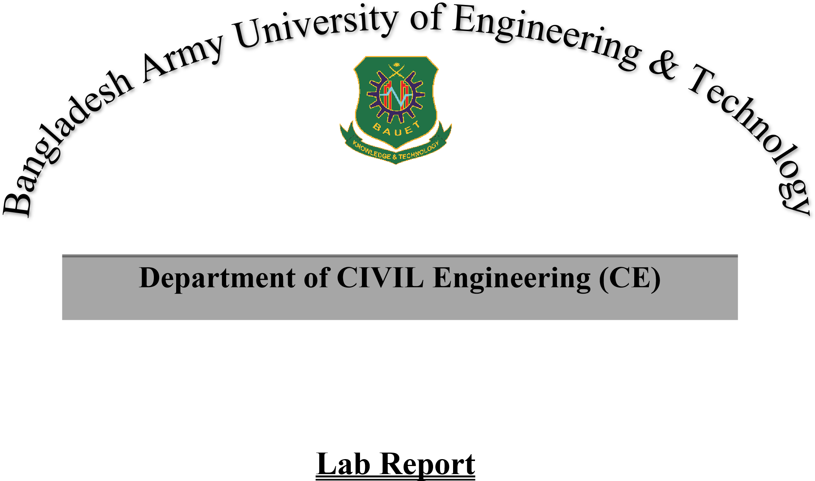
Course Code | ꓽ MES -1202
Course Title | ꓽ Mechanical Engineering Shops
Credit Hour | ꓽ 1.5
Semester | ꓽ Summer 2026
Remarks

 | Submitted by |  | Submitted to
 | Name of Student | ꓽ Md. Sabbir Hossain | Name of Teacher | Maj Md. Abdul Hamid (Retd).
 | Student ID | ꓽ 0812520205081009 | Designation | Assistant Professor
 | Year & Semester | ꓽ 1st Year 2^{𝑠𝑡} Semester | Name of Teacher | Istiak Ahmed Fahim.
 | Group | ꓽ 0 | Designation  Dept. | :Lecturer  :ME
 | Date of Final Submissionꓽ Signature of the Teacher

